2 Reports:

* SNAP – how all funding was distributed (program
* Department of Labor – who is applying for jobs, getting jobs, training and education, etc…

Only Active participants – even if they are active in that period even 1 day

Represented here: Comp

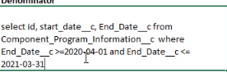

The reports are critical. Currently being created manually

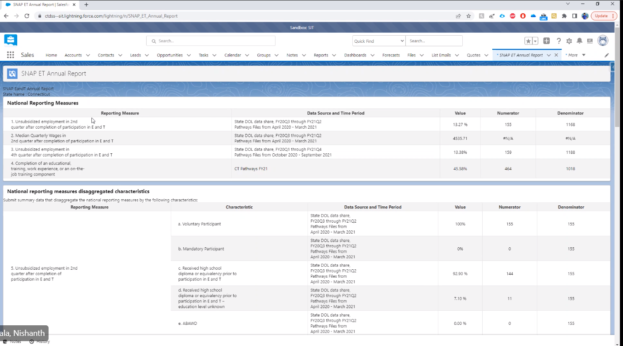

Multiple sections on the Report

Groups (Reporting Measures) and Subcategories (Characteristic)

ABAWD – no logic yet

AURA component

Javascript call Apex class

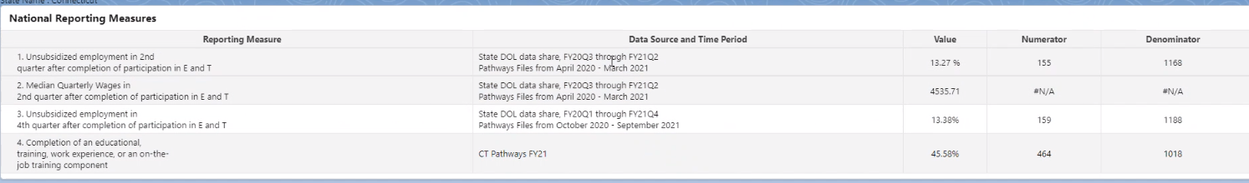

Labels are dynamic based on the timeframe being reported

Value is Numerator / Denominator

Query:

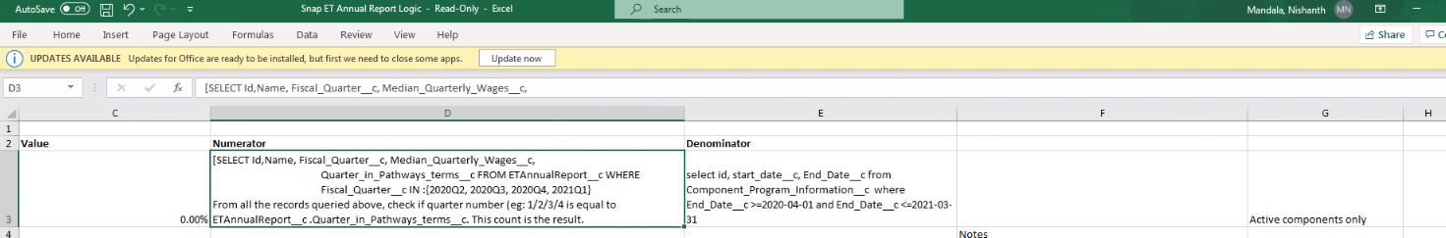

Pathways Q1 starts from October previous year

End of year

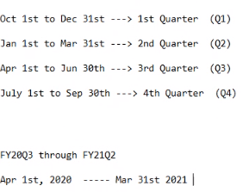

DOL is different

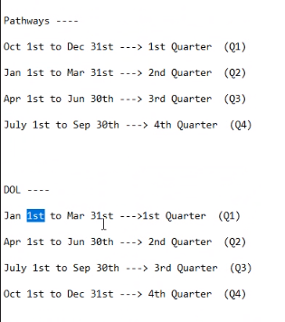



SOQL for the Numerator

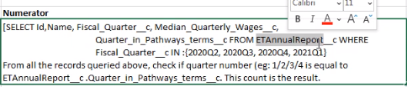

Salesforce Inspector for queries:

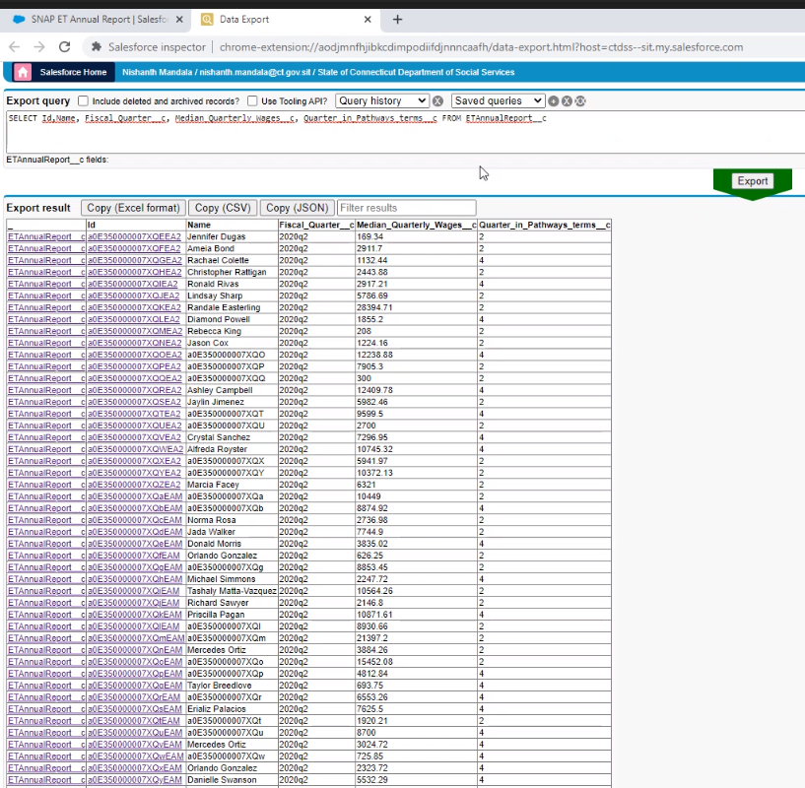

Quarter could be blank…only include where quarter is 1, 2, 3 or 4

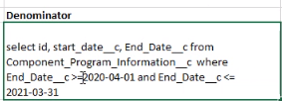

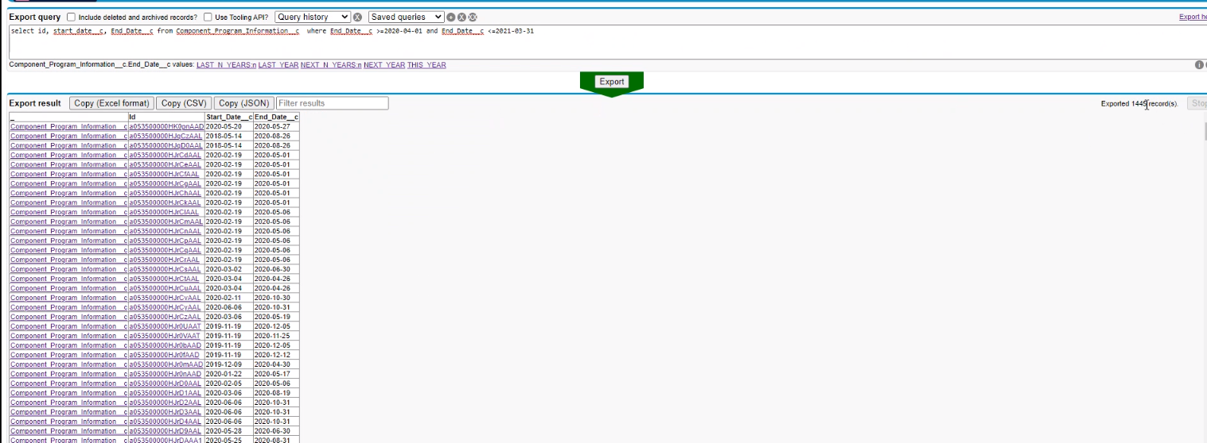

Count does not match report:

Because there are duplicate components

Contact = participant

Participant can participate in multiple programs, and some programs could appear multiple times

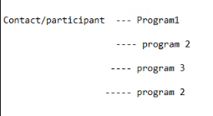

Filter out the duplicate program 2s…

Logic is in CohortController

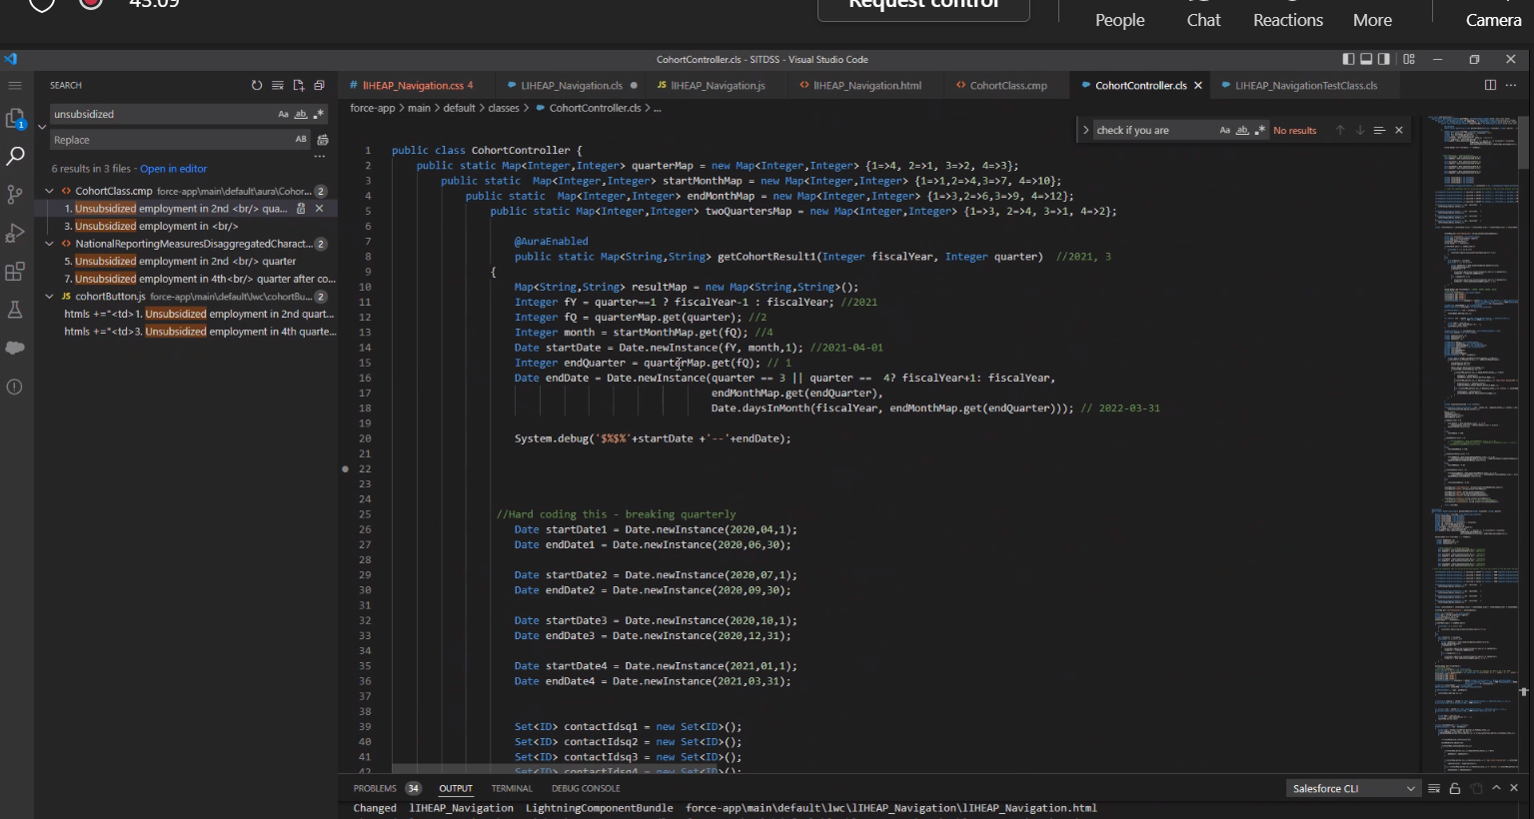

CohortClass is the component name

ETAnnualReport

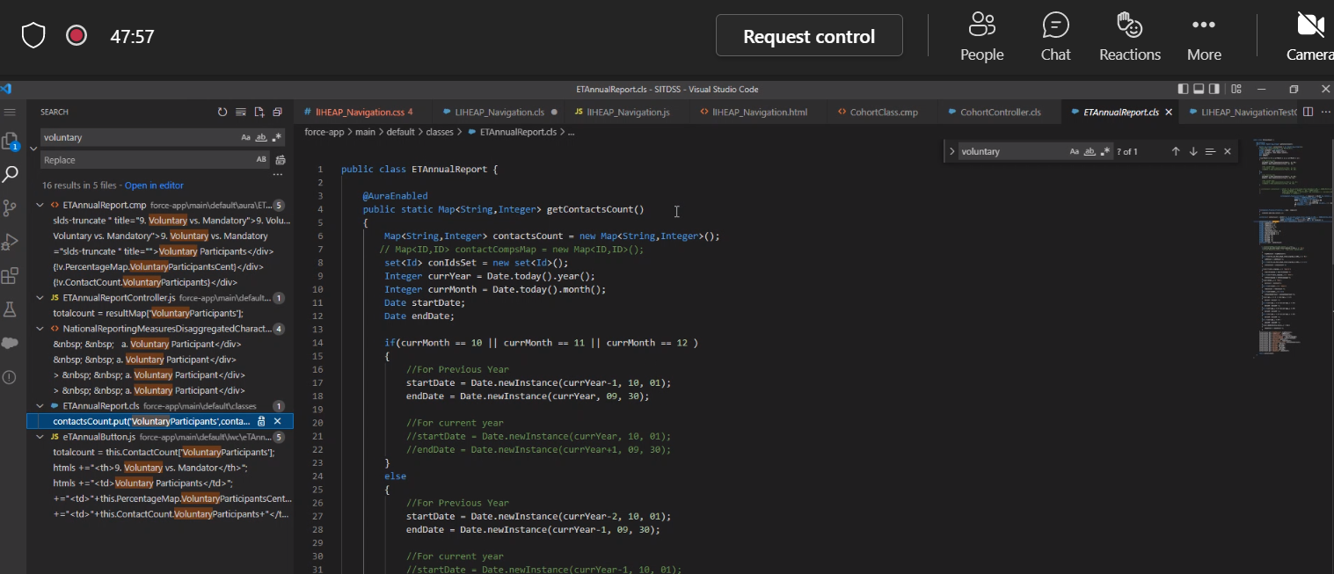

Salesforce – create a code report

Biz sends to DOL (active participants)

They update the money earned

That’s the file we upload here

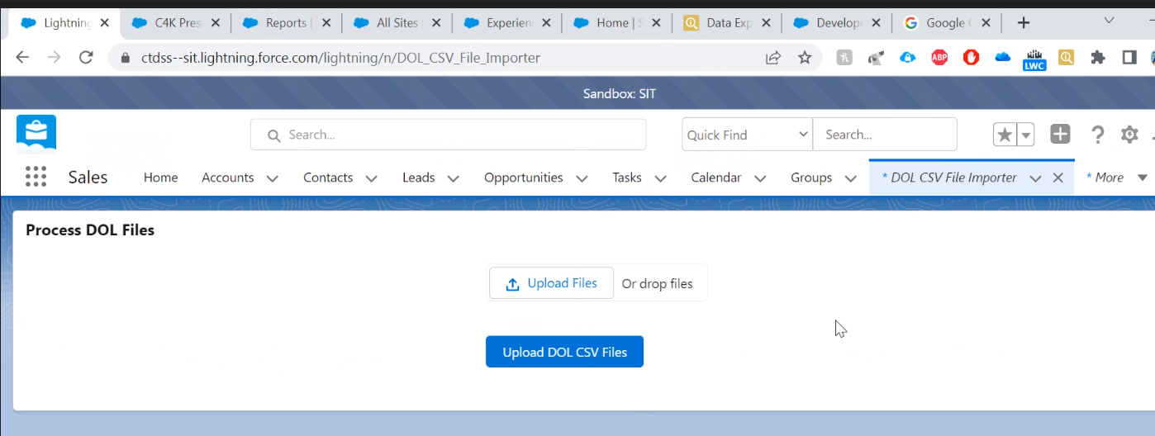

For this report

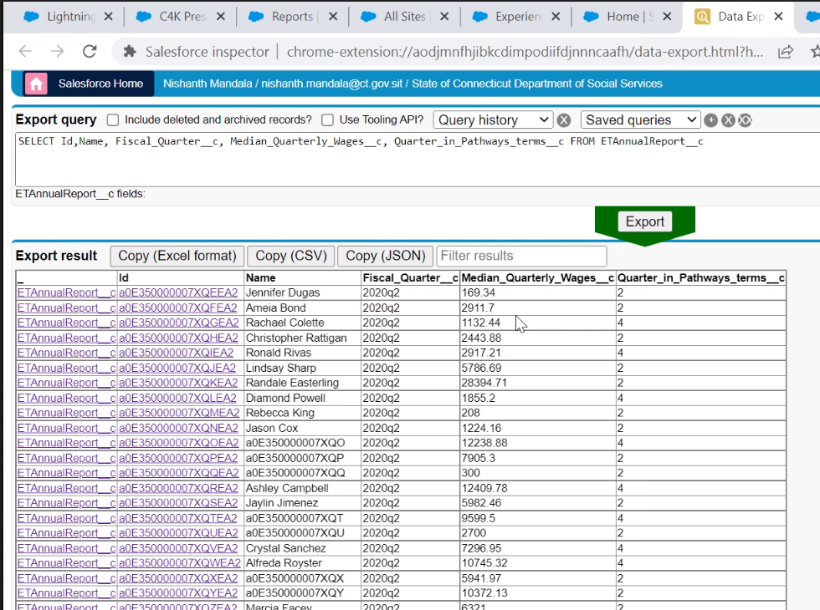

Invoicing

Migrated to prod, but not being used yet

Outstanding issues:

Report